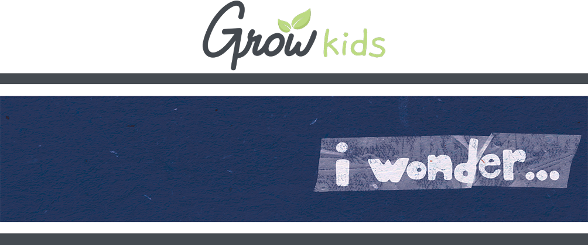
FOR FAMILIES

Hey, families! Here's a look at what we're covering with your kids so you can help them continue to grow at home while VBS is going on.

GROW AT HOME | DAY 1

TODAY  On day 1 of I Wonder, kids discover how God created and saved everyone for a purpose.  - THE BIG IDEA: I wonder what makes my story unique?  - THE BIBLE: Ephesians 2:4-10  ASK THIS  Because sometimes you and your kid need a conversation-starter that isn't, "So . . . how was VBS?"  - How have we been saved?  - Who are some people you can share your story with? | REMEMBER THIS  This VBS, your kids are memorizing the Bible verse Psalm 40:5a (NIV), in case you want to work on them together.  NEXT DAY  Next time, kids discover how they can use their gifts for God!
FOR FAMILIES

Hey, families! Here's a look at what we're covering with your kids so you can help them continue to grow at home while VBS is going on.

GROW AT HOME | DAY 1

THIS SESSION  On day 1 of I Wonder, kids discover how God created and saved everyone for a purpose.  - THE BIG IDEA: I wonder what makes my story unique?  - THE BIBLE: Ephesians 2:4-10  ASK THIS  Because sometimes you and your kid need a conversation-starter that isn't, "So . . . how was VBS?"  - How have we been saved?  Who are some people you can share your story with? | REMEMBER THIS  This VBS, your kids are memorizing the Bible verse Psalm 40:5a (NIV), in case you want to work on them together.  NEXT DAY  Next time, kids discover how they can use their gifts for God!

