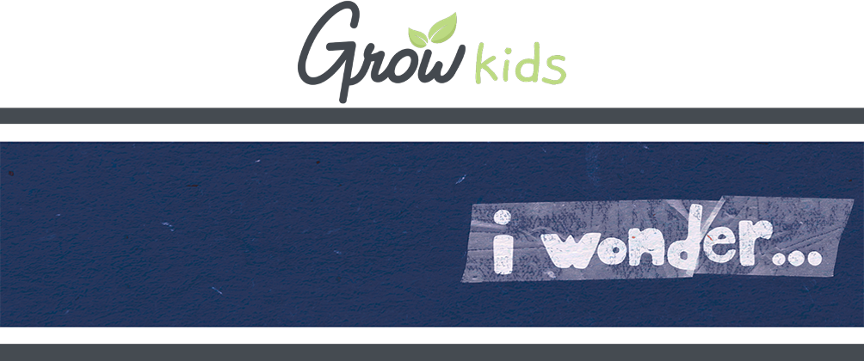
FOR FAMILIES

Hey, families! Here's a look at what we're covering with your kids so you can help them continue to grow at home while VBS is going on.

GROW AT HOME | DAY 2

TODAY  On day 2 of I Wonder, kids discover how they can use their gifts for God.  - THE BIG IDEA: I wonder what gifts God gave me?  - THE BIBLE: I Peter 4:10;  II Timothy 1:6-7  ASK THIS  Because sometimes you and your kid need a conversation-starter that isn't, "So . . . how was VBS?"  - What are some gifts God has given you?  - Can you think of a way you can use those gifts for God? | REMEMBER THIS  This VBS, your kids are memorizing the Bible verse Psalm 40:5a (NIV), in case you want to work on them together.  NEXT DAY  Next time, kids discover how they can love others like God does!
FOR FAMILIES

Hey, families! Here's a look at what we're covering with your kids so you can help them continue to grow at home while VBS is going on.

GROW AT HOME | DAY 2

TODAY  On day 2 of I Wonder, kids discover how they can use their gifts for God.  - THE BIG IDEA: I wonder what gifts God gave me?  - THE BIBLE: I Peter 4:10;  II Timothy 1:6-7  ASK THIS  Because sometimes you and your kid need a conversation-starter that isn't, "So . . . how was VBS?"  - What are some gifts God has given you?  - Can you think of a way you can use those gifts for God? | REMEMBER THIS  This VBS, your kids are memorizing the Bible verse Psalm 40:5a (NIV), in case you want to work on them together.  NEXT DAY  Next time, kids discover how they can love others like God does!

