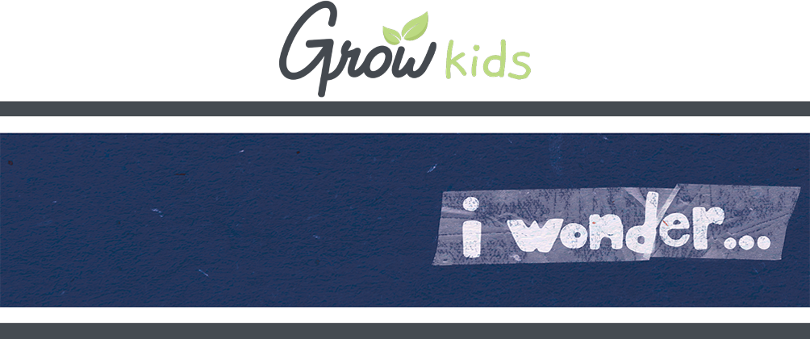
FOR FAMILIES

Hey, families! Here's a look at what we're covering with your kids so you can help them continue to grow at home while VBS is going on.

GROW AT HOME | DAY 3

TODAY  On day 3 of I Wonder, kids discover how they can love others like God does.  - THE BIG IDEA: I wonder what I can learn from others?  - THE BIBLE: I John 4:11, I Peter 4:8  ASK THIS  Because sometimes you and your kid need a conversation-starter that isn't, "So . . . how was VBS?"  - Why do you think God wants us to show love to everyone?  - How can learning about and learning from others help us love them? | REMEMBER THIS  This VBS, your kids are memorizing the Bible verse Psalm 40:5a (NIV), in case you want to work on them together.  NEXT DAY  Next time, kids discover how they can live their lives for God!
FOR FAMILIES

Hey, families! Here's a look at what we're covering with your kids so you can help them continue to grow at home while VBS is going on.

GROW AT HOME | DAY 3

TODAY  On day 3 of I Wonder, kids discover how they can love others like God does.  - THE BIG IDEA: I wonder what I can learn from others?  - THE BIBLE: I John 4:11, I Peter 4:8  ASK THIS  Because sometimes you and your kid need a conversation-starter that isn't, "So . . . how was VBS?"  - Why do you think God wants us to show love to everyone?  - How can learning about and learning from others help us love them? | REMEMBER THIS  This VBS, your kids are memorizing the Bible verse Psalm 40:5a (NIV), in case you want to work on them together.  NEXT DAY  Next time, kids discover how they can live their lives for God!

