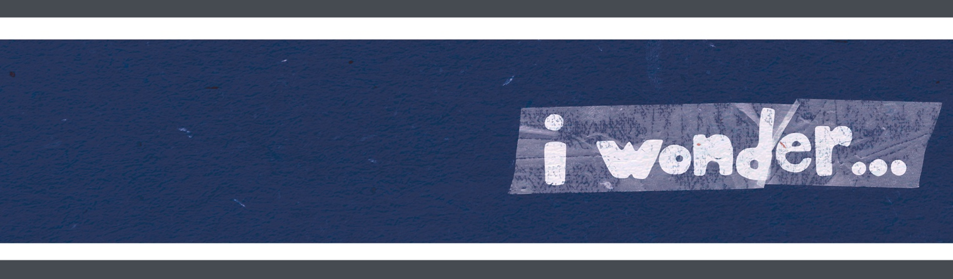
DAY 1
SMALL GROUP GUIDE

THE BIG IDEA
I wonder what makes
my story unique?

THE BIBLE
Created and Saved by God:
Ephesians 2:4-10

QUESTIONS

- What has God done for us even though we make mistakes?
- How have we been saved?
- Why did God create us?
- Read Ephesians 2:8–9. Why do you think God saved us by grace through faith instead of through our own works?
- What do you think it means to be "God's handiwork"?
- What is something that happened in your life that shows that God was a part of that story?
- Who are some people you can share your story with?

ACTIVITY

Give each kid a copy of the printable. Have kids color or paint the parts then stamp their handprint in the middle to create a rocket.

When we begin to wonder what God can do in and through our unique stories, our lives have the chance to—like rockets—launch into things that are out-of-this-world amazing!

MEMORY VERSE OF THE MONTH: Psalm 40:5a (NIV)
Many, Lord my God, are the wonders you have done, the things you planned for us.

Looking for memory verse sign language you can share with your families and volunteers?
Go to growcurriculum.org/Psalm40-5a and share away!

w

