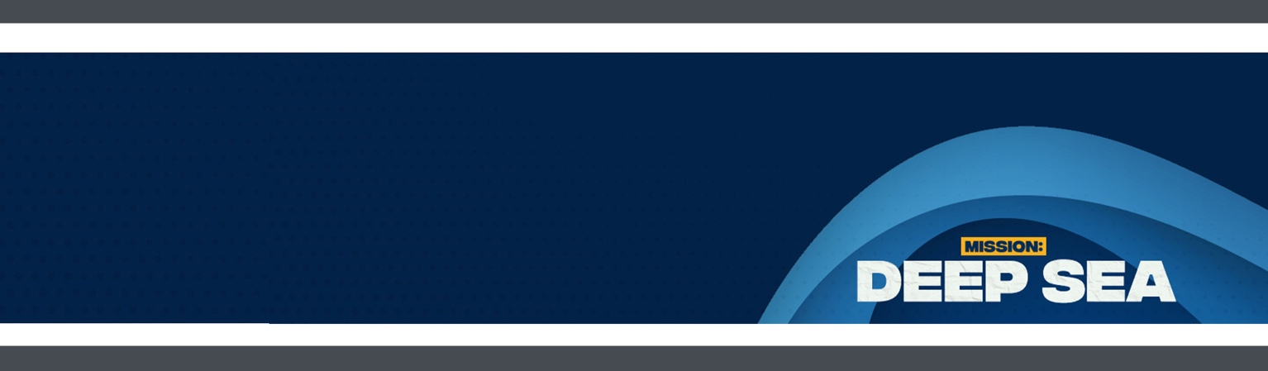
SESSION 1
SMALL GROUP GUIDE

BIG IDEA
People can help my
faith grow.

THE BIBLE
Moses and the Red Sea:
Exodus 14

Wait for cues from your VBS leader throughout the day about when you will be breaking off into small groups for the activities listed below. We suggest you have a designated area where you can keep your group's crafts and other personal items so that they can collect them all at once when it's time to leave.

ACTIVITY | S.E.A. Agent Badge
- INSTRUCTIONS: Have kids create their own S.E.A. agent badge to wear during VBS.

ACTIVITY | Crossing the Sea
- INSTRUCTIONS: Gather your group and work together to cross the sea, picking up sea shells as they go. Hold on to these sea shells for the Big Idea activity.

THE BIG IDEA | People can help my faith grow.
- INSTRUCTIONS: Groups will work together to unscramble the Big Idea for the day.

DISCUSSION
- Who were Moses and the Israelites running from? Pharaoh and his army.
- When Pharaoh's army was getting closer to them, what did the Israelites ask Moses? Why did you bring us here? What have you done?
- What did God tell Moses to do that made the water part? Stretch out his hand.
- Read Exodus 14:13-14. Why did Moses tell the people they need only to "be still"?
- Have you ever been in a situation where you thought you had no way out? What happened?
- What do you think it means for your faith to grow?
- Who is someone who has helped your faith grow? How?

REFLECTION | Tentacles of Faith
- INSTRUCTIONS: Tell the kids to think of the name of someone who has helped their faith grow and encourage them to write down that person's name on a strip of purple paper. They can write as many as they want. Once everyone in the group has written down some names, staple the strips of paper together to form a chain. Then attach your chain to the giant octopus in the main meeting room.

MEMORY VERSE | Ephesians 3:18
- INSTRUCTIONS: Tell the kids to carefully write each word of the memory verse on strips of green crepe paper, one word per piece of "seaweed." Then glue the seaweed strips in the correct order onto blue construction paper.

ACTIVITY | Fish Key Chain Craft
- INSTRUCTIONS: Form a heart shape in the center of the pipe cleaner and twist below it several times. Thread beads on both pipe cleaner ends. Add the keychain ring, then twist ends together to secure it. Assist the kids in hanging their fish on their S.E.A. Agent badge.

MEMORY VERSE FOR MISSION: DEEP SEA: Ephesians 3:18 (NIV)

“Grasp how wide and long and high and deep is the love of Christ.”
Looking for sign language? Go to growcurriculum.org/Ephesians3-18 and get memorizing!

