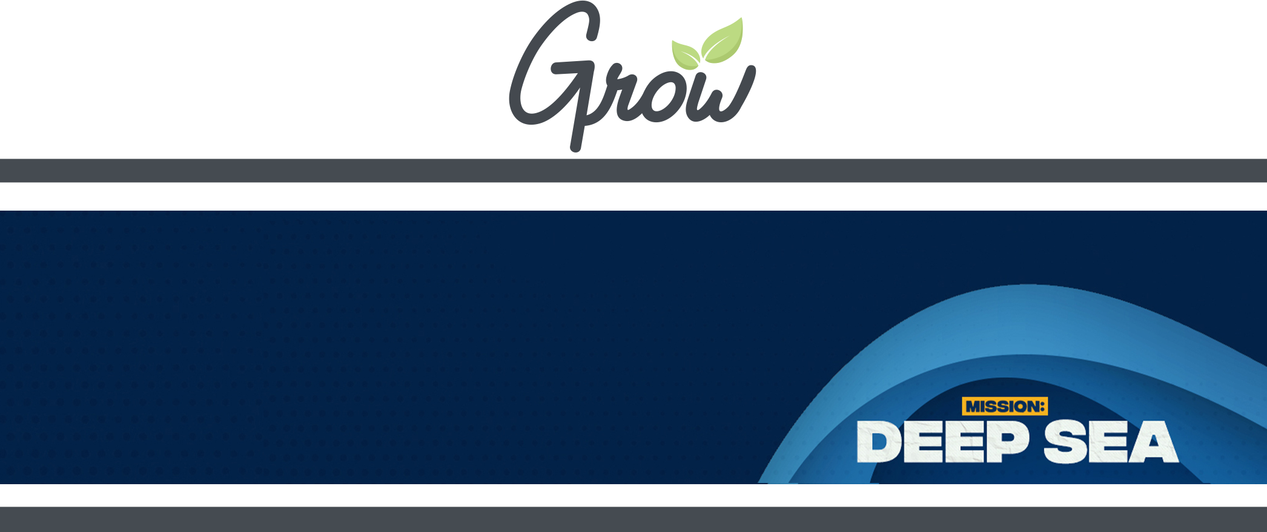
SHOP & PREP LIST

SESSION 1

ACTIVITY | Sticky Toes
- Buckets or small dish tubs
- blue jello
- small, plastic sea creatures
- baby wipes, paper towels, etc.
WHAT TO PREP:
- Make blue jello with sea creatures inside.
- Fill kiddie pools with jello and sea creatures

ACTIVITY | Crossing the Sea
- brown butcher paper
- blue bed sheets
- small, plastic sea creatures
- baby wipes, paper towels, etc.
WHAT TO PREP:
- Set up crossing the red sea brown paper and blue sheets.
- Print Crossing the Sea printable.

SCRIPTURE | Exodus 14
- Moses and Pharaoh action figures
- red jello mold
- plastic knife
WHAT TO PREP:
- Make red jello mold

OBJECT LESSON | Parting of the Red Sea
- Water bottles
- Olive oil
- Blue food coloring

SNACK | Snack of the Sea
- large bowl
- dixie cups
- hand sanitizer
- colored Goldfish crackers
- blueberries
- Cheerios
REFLECTION | Tentacles of Faith
- purple slips of paper
- pens or pencils
- staplers
- Scotch tape
- large post board or wood
- purple paint
WHAT TO PREP:
- Create a large purple octopus by cutting out a large circle out of poster board or wood.
- Paint octopus purple
- Hang on stage

ACTIVITY | Red Sea Sprint
- water balloons
- ribbon
- ground stakes
WHAT TO PREP:
- Place ground stakes and blue ribbon to create lanes for teams
- Fill water balloons for each team

MEMORY VERSE | Ephesians 3:18
- roll of green crepe paper
- glue sticks
- blue construction paper

ACTIVITY | Fish Key Chain Craft
- pipe cleaners
- assorted tri-beads
- keychain rings

SESSION 2

ACTIVITY | Lunch Launch
- fake loaves of bread
- fake fish or fish shapes cut from sponges
- baskets
- optional: water balloon launcher, large laundry baskets

ACTIVITY | Lunch is Served Craft
- paper plates
- pipe cleaners
- hole punch
- crayons
- scissors
- glue
WHAT TO PREP:
- Print Lunch is Served printable

SCRIPTURE | John 6:1-13
- dinner rolls
- candy fish
WHAT TO PREP:
- Prepare baskets of candy fish and dinner rolls and hide them in the back of the room.

THE BIG IDEA | My faith grows deeper when I use my gifts.
- index cards
- sharpies
- dish tub, kiddie pool, or bucket of sand
- tarp or plastic tablecloths

ACTIVITY | I Draw, You Draw
- blank copy paper
- optional: clipboards

SNACK | Sea Snack Mix
- bowls
- small scoops
- snack size ziplock bags
- blue jelly beans
- gummy sharks
- Goldfish crackers

REFLECTION | Finger Print Fish
- poster board
- washable ink pads in varying colors
- sharpie
- scissors
- baby wipes
WHAT TO PREP:
- Draw fish on poster boards for each group.

REFLECTION | Finger Print Fish
- yellow or gold dessert party plates
- pencils
- small treasure chest

MEMORY VERSE | Ephesians 3:18
- scissors
- hole punch
- twine, ribbon
WHAT TO PREP:
- Print Memory Verse printable.

ACTIVITY | Deep Diver Craft
- Insta-Max/Polaroid camera (or substitute)
- scissors
- glue
- crayons
WHAT TO PREP:
- Print Deep Diver printable
- Take headshot photo of each kid beforehand and print photos

SESSION 3

ACTIVITY | Beach Ball Bounce
- beach balls
- permanent marker
WHAT TO PREP:
- Blow up a beach ball for each group
- Write questions from Beach Ball Bounce on the ball

ACTIVITY | Octopus Tag
- ground stakes
- ribbon
- optional: octopus hat
WHAT TO PREP:
- Mark out a large square using stakes and ribbon for a playing zone.

ACTIVITY | Sunken Treasure
- Pencils
- sunken treasure map printable
- gold chocolate coins

THE BIG IDEA | My faith grows deeper when I spend time with God.\
- diving sticks
- sharpies
- blue kiddie pool
WHAT TO PREP:
- Write the BIG IDEA on one of the diving sticks.
- Fill a blue kiddie pool with water.

OBJECT LESSON | Salvation
- construction paper

SNACK | Sandy Shores
- vanilla pudding cups
- graham cracker crumbs
- clear plastic cups
- spoons
- blue food coloring

REFLECTION | Water Beads
- shallow bowls or dishes
- water beadsl

REFLECTION | Sea Shells
- sea shells

MEMORY VERSE | Ephesians 3:18
- mini bottles of bubbles
ACTIVITY | Deep Sea Coral Painting Craft
- paper plates
- washable paint
- straws
WHAT TO PREP:
- Deep-Sea Coral Painting printable
- Print Deep-Sea Coral Painting printable

SESSION 4

ACTIVITY | Swimming Fish
- large plastic soft drink bottles
- water
- sand
- blue food coloring
- balloons
- sharpies

ACTIVITY | Jump the Waves
- long ropes

ACTIVITY | Spitting Jonah
- blue colored copy paper
- small pom poms
- optional: googly eyes, glue
- optional: toy boat

THE BIG IDEA | My faith grows deeper when I share my story.
- Permanent markers
- magnetic fishing set
- kiddie pool
- optional: dowel rods, string, magnets, paper clips, fish printable

OBJECT LESSON | Dominoes
- dominoes
- permanent markers

SNACK | Clam Cookies
- vanilla wafers
- colored frosting
- candy pearls
- plastic knives

RESPONSE | Sharing Your Story
- fishing net
- fish cutout printable
- clothespins
- pencils
WHAT TO PREP:
- Hang fishing net on stage
- Print Sharing Your Story printable

ACTIVITY | S.E.A. Agent Certificate
- S.E.A. Agent certificate printable
- pencils
WHAT TO PREP:
- Print S.E.A. Agent certificate printable

ACTIVITY | DIY Aquarium Craft
- plastic mason jars
- blue food coloring
- plastic aquarium fish, creatures, and figurines
- aquarium rocks and plastic plants
- 2" round Avery labels
- Lid Sticker printable
- optional: glitter, hot glue and hot glue gun
WHAT TO PREP:
- Print Lid sticker printable on 2” round Avery labels

SESSION 5

EVENT | Water Wars
- bubbles
- bubble wands
- kiddie pool
- water tables
- funnels, watering cans, etc.
- beach balls
- new trash cans
- water blaster
- buckets
- cups
- kiddie pool
- sponges
- water balloons
- 100 ft heavy-duty plastic sheeting
- landscaping anchor pins
- hammer
- liquid soap
- hose with sprayer
WHAT TO PREP:
- Fill kiddie pools with bubble solution.
- Blow up beach balls.
- Prep giant slip ‘n slide.

EVENT | Trip to local aquarium
- tickets to aquarium
- snacks
- optional: child line keepers, event t-shirts WHAT TO PREP:
- Purchase tickets, check out group discounted rates.
- Collect release forms from parents.
- Arrange transportation.

EVENT | Movie Day
- movie
- snacks
WHAT TO PREP:
- Preview movie choice before event (see suggested list in lesson guide).
- Prep snacks.
- Review church CVLI license.

EVENT | Recreational Water Play
- snacks
- sunscreen
- water bottles or other drinks
- optional: water toys, pool floaties or life jackets
WHAT TO PREP:
- Decide on a local swimming pool, water park, or beach.
- Check weather forecast and prep back up plan in case of inclement weather.
- Purchase tickets if necessary, check out group discounted rates or rental options.
- Collect release forms from parents.
- Arrange transportation.
- Prep and pack snacks or lunch for kids.

PLAY STATIONS

STATION 1 | Motion of the Ocean
WHAT TO PREP:
- Print out page containing all the motions for this station.

STATION 2 | Sea Creature Creations
- Play Doh
- ocean shaped cookie cutters
- rolling pins

STATION 3 | Water Beads
- water beads
- tarp
- kiddie pool
- shovels, scoops, other water toys
WHAT TO PREP:
- Put water beads in kiddie pool with water to expand the beads.

STATION 4 | High Seas Exploration
- pencils
- optional: clipboards
- optional: ocean animal toys
WHAT TO PREP:
- Print High Seas Exploration printable.
- Place ocean themed scavenger hunt items around the VBS space.

STATION 5 | Book Corner
- books about the ocean, in varying reading levels
- optional: rug, bean bag chairs or other seating options

STATION 6 | Sand Castle Build Off
- kinetic sand
- shovels, scoops, and other sand toys
- tarp
- optional: pie pans or cookie sheets for kids to build on

STATION 7 | Float Your Boat
- kiddie pool
- aluminum foil
- tape
WHAT TO PREP:
- Fill kiddie pool with water.

STATION 8 | Bible Verse Go Fish
WHAT TO PREP:
- Print Bible verse go fish cards printable

